**National University of Computer and Emerging Sciences, Lahore Campus**

**Assignment 2 Database System**

**TOPIC: SQL + RA**

**Deadline: 27 March, 2023 in class**

**Consider the following table structures. Write SQL Query and RA both for each question.**

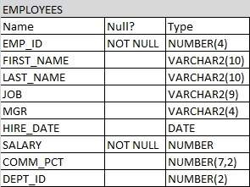

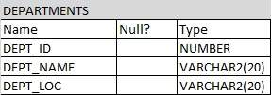

**Q1. You need to find out the names and IDs of the departments in which the least salary is greater than the highest salary in the department 10.**

**Q2. Write a query to find the employees whose salary is equal to the salary of at least one employee in department of id 10.**

**Q3. You need to find out all the employees who have salary greater than at least one employee in the department 10.**

**Q4. You need to find out all the employees who have salary lesser than the salary of all the employees in the department 10.**

**Q5. You need to find out all the employees who have their manager and department matching with the employee having an Employee ID of 121 or 200.**

**Q6. You need to find the department name of an employee with employee ID 200.**

**Q7. You need to find the highest earning employee with the job ID as 'SA_REP'.**

**Q8. You need to find the job which has at least one employee in it.**

**Q9. You need to find the job which has no employees in it.**

**Q10. You need to find the 3rd maximum salary from the EMPLOYEES table.**